FSHS Manuscript Structure for “Traditional” Papers
Title
Effect of Ratooning X17-2 x T5 Papaya Plants on Crop Yield and Survival

Author name(s) First (MI – optional) Last¹
Wanda Montás¹, Pamela Moon¹, Jonathan Crane¹*, and James Colee²

Location Primary location (not in bold), University or other Affiliation, City, State (country if outside USA)
¹Tropical Research and Education Center, University of Florida, IFAS, Homestead, FL **
²Statistical Consulting Unit, University of Florida, IFAS, Gainesville, FL
**(Do NOT include departments if your primary location is a research station)
Author email
*Corresponding author: jhcr@ufl.edu
Acknowledgements
Thanks to anyone assisting with this project should go here.
This section should include any grant funding using a complete citation
Keywords. pollarding, GMO, pawpaw, papayier, du du

Abstract. Selected plants in a three-year-old 0.3-acre papaya ringspot virus resistant, transgenic X17-2 x T5 (Accession 2562) papaya planting were used to: a) compare the yield from single-stemmed and multiple-stemmed plants (Trial 1) and; b) to compare the yield of plants cut at different heights (Trial 2). The original planting sustained significant damage after a brief but intense tropical storm on 19 June 2014. Some plants lost their apex and most plants had small side-shoots left intact. On 2 February 2015 (Trial 1), 15 bisexual plants were cut to 120 cm above the soil line, removing the main trunk; the main trunks of 15 other bisexual plants were left intact. On 3 March 2015 (Trial 2), 16–32 randomly selected bisexual or female plants were left intact or cut to 30 cm, 60 cm, 90 cm, or 120 cm above the soil line. Fruit production was evaluated by counting the number of fruit per plant over seven harvests and five harvests in Trial 1 and 2, respectively. In Trial 1, there was no significant difference in mean number of fruit among plants with or with-out the main trunk left intact. Mean fruit per plant ranged 0.3–17 fruit per plant. In Trial 2, there was no significant difference in mean number of fruit per harvest among plants cut to 60 cm, 90 cm, and 120 cm; all plants cut to 30 cm died prior to the first harvest. Mean fruit per plant ranged 0.3–16 fruit per plant.
Introduction (do not include the word “introduction” in the paper
Papaya (Carica papaya L.) is large, primarily single-stemmed, potentially long-lived herbaceous tropical plant that produces a fruit column just below the apical leaves (Villegas, 1991). Papaya is grown commercially throughout the tropical and warm subtropical regions and its production, consumption and international trade are increasing (Evans et al., 2015). Areas in the United States with papaya production—in order of acreage and value—are the Hawaiian Islands (~2,025 acres), Puerto Rico (~700 acres), Florida (~300 acres), Texas (no data), and California (no data) (U.S. Census, 2017; FactFish, 2017).
Materials and Methods
Selected plants in a three-year-old, 0.3-acre, PRV-resistant, transgenic X17-2 x T5 (Accession 2562) papaya planting at the University of Florida Tropical Research and Education Center, Homestead were used to: a) compare the yield from single-stemmed and multiple-stemmed plants (Trial 1) and; b) to compare yield of plants cut at different heights, allowed to branch and fruit (Trail 2). The trees were established in 2012. They were spaced 7 ft in-row and 12 ft between rows and planted in plastic beds with two lines of drip-tape per bed (Menocal-Barerena, 2014). Plants were fertigated through the irrigation system with 4–0–8 (N–P–K) fertilizer and sprayed periodically with minor elements. Two-spotted mites (Tetranchus urticae Koch) were controlled with periodic releases of mite predators (Fasulo and Denmark, 2016) and/or applications of commercially available strains of Beauvearia bassiana (e.g., BotaniGard®). Papaya fruit flies (Toxotrypana curvicauda Gerstaecker) were controlled with Tanglefoot®-covered green Styrofoam balls placed just below the fruit column (Seleman et al., 2015).

Results and Discussion***
Trial 1: single-stemmed and multiple-stemmed plants. There was no significant treatment—harvest date interaction and no significant difference among treatments in the mean number of fruit per plant for any harvest (Fig. 2). This suggests other factors, such as environmental conditions, were more important in affecting fruit production than the applied treatment.
*** (This can be split into Results and a separate section for Discussion
Summary ****
The yield from single- and multi-stemmed papaya plants was comparable. Production from GM-papaya plants cut at 60–120 cm above the soil line was similar over a 586-day period. The combination of PRV-resistance and cutting plants to force ratoon cropping may enable continued plant growth and production despite the presence of PRV in the production area, prolong the period of efficient harvesting (i.e., harvesting from the ground), and potentially reduce the necessity of replanting papaya fields every 2–3 years.
**** This section is optional
Literature Cited
Please use the NEW FSHS Proceeding Literature Cited Formatting Chart (separate document)

[PLEASE PUT TABLES ON SEPARATE PAGES AT THE END OF THE PAPER]
Note: if your table is very wide, use <layout>, <breaks>, <section break> <continuous> to change that page/those pages to landscape orientation
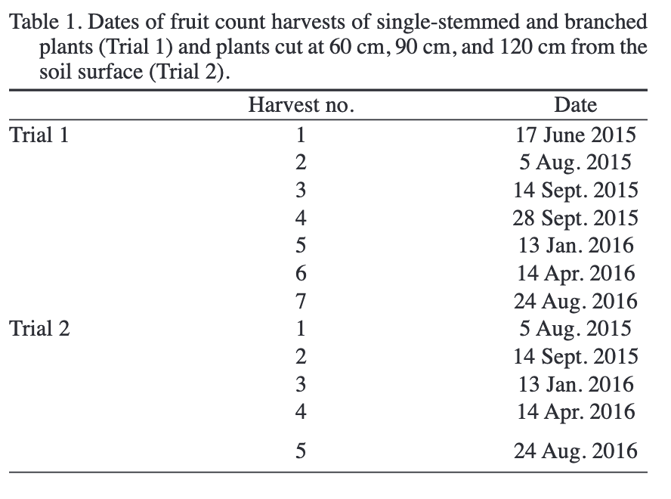

[PLEASE PUT FIGURES AT THE END OF THE MANUSCRIPT. Use Fig. and the figure number at the bottom of the figure. Please include high-quality images for all figures. You may want to include an outline around photos.
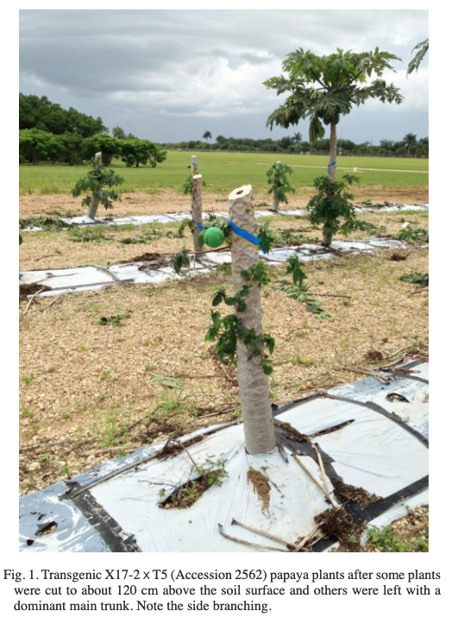
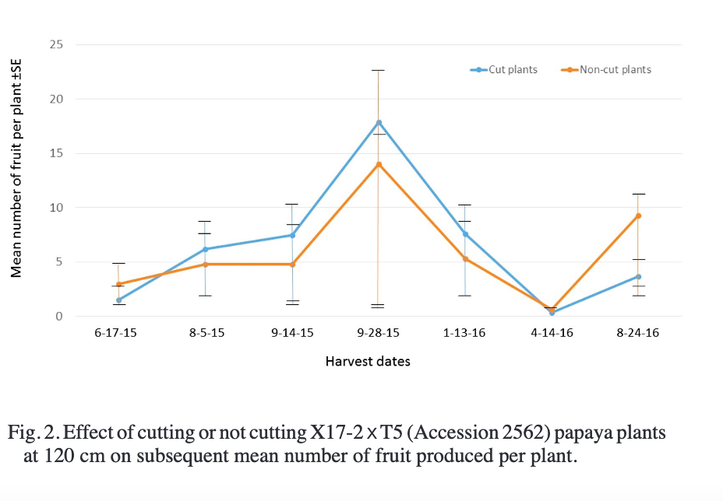

Note: only the first paragraph of each section of the paper has been included. There are samples of tables, figures and photos. Source: Proc. Fla. State Hort. Soc. 130: 2017. https://journals.flvc.org/fshs/article/view/114229/109542

